Unit 3

MARKET STRUCTURE

Managers must tailor their decisions to the specific market environment in which their firms operate. For example, a manager of a business that is the patent holder and the only supplier of a new wonder drug will act differently than a manager of a firm trying to survive in the very competitive fast-food industry. Because the decision-making environment depends on the structure of the market, it follows that no single theory of the firm can adequately describe all of the conditions in which firms operate.

Number and Size Distribution of Sellers

The ability of an individual firm to affect the price and total amount of a product supplied to a market is related to the number of firms providing that product. If there are numerous sellers of nearly equal size, the influence of any one firm is likely to he small. In contrast, in a market consisting of only a few sellers, an individual firm can have considerable impact on price and total supply.

Number and Size Distribution of Buyers

Markets can also be characterized by the number and size distribution of buyers. Where there 2tre many small purchasers of a product, all buyers are likely to pay about the same price. However, if there is only one purchaser, that buyer is in a position to demand lower prices from sellers. Similarly, if a market consists of many small buyers and one or a few firms making volume purchases, the larger firms may be able to buy at lower prices. For example, because of their sales volume, IBM and AT&T may be able to obtain electronic components at prices below those of competitors.

Product Differentiation

Product differentiation refers to the degree that the output of one firm differs from that of other firms in a market. Where products are undifferentiated, decisions to buy are made strictly on the basis of price. In these markets, sellers who attempt to charge a higher price are unable to sell their output. If there is no difference in price, the buyer has no preference as to sellers, Wheat is a good example of an undifferentiated product. Although there are several grades, all wheat of a given grade sells for the same price in a given market.

Product differentiation is an important market characteristic because it indicates a firm's ability to affect price. If a firm's product is perceived as having unique features, it can command a premium price. However, products considered less desirable will be purchased only if the seller is willing to accept a lower price. For example, consumers will pay extra for fresh San Francisco sourdough bread, but will buy day-old Wonder Bread only if the price is substantially reduced.

Conditions of Entry and Exit

Ease of entry and exit are crucial determinants of the nature of a market in the long run. When it is extremely difficult for new firms to enter, existing firms will have much greater freedom in making pricing and output decisions than if they must be concerned about new entrants who have been attracted by the lure of high profits. Consider a drug manufacturer that holds a patent that prohibits other firms from making the drug. If there are no close substitutes for the product, that firm will essentially be free from competition now and for the duration of the patent.
Ease of exit also affects managerial behavior. Suppose that certain firms in a market have been earning less than the normal rate of profit. If the resources used to produce the product can easily he transferred from one use to another, some of those resources will be shifted to other industries, where they can earn a higher rate of return. However, if the resources are highly specialized, they may have little value in another industry. For example, te track and terminals of an unprofitable railroad may have few alternative uses, and may only be sold for their salvage value. This makes exit more difficult and costly.

PERFECT COMPETITION

The term perfect competition is something of a misnomer. In a perfectly competitive world there really is no overt competition between economic units. As buyers and sellers make business decisions, they do not have to take into account the effect of their actions on other participants in the market. The reason is that the individual economic units in perfect competition are so small relative to the. total market that their actions have no perceptible impact on other buyers and sellers. Hence, decisions can be made without considering the reactions of others. In perfect competition, market participants do not compete against one another. Rather, they make decisions in an economic environment that they perceive as being fixed or given.

Characteristics
The concept of perfect competition can be defined in terms of the market structure characteristics of the preceding section.

- First, there must be a large number of sellers in the market with no single seller able to exert significant influence over price.
- Similarly, the second requirement for perfect competition is that there be a large number of small buyers, each buyer being unable to influence price. That is, all buyers are price takers.
- Third, perfect competition assumes easy entry and exit from an industry. If price is above cost, resulting in economic profits, resources can be mobilized to create new firms or to expand the production capacity of firms already in the industry.
- Finally, under perfect competition, it is assumed that the product is totally undifferentiated. One firm's output cannot be distinguished from that of other producers. As a result, purchasing decisions are based entirely on price.
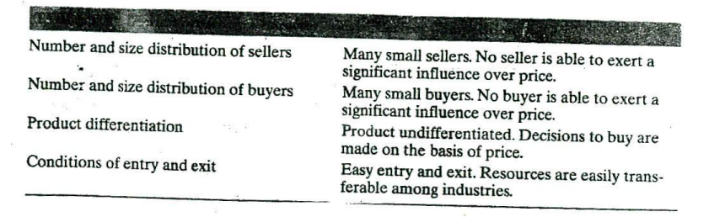
The Equilibrium Price

In the preceding section, reference was made to the market-determined price. Although no single entity in a perfectly competitive, market can affect price, the aggregate effect of the participants in the market is important in price determination. Indeed, the interaction of supply and demand determines the equilibrium price and the quantity to be exchanged. Consider a hypothetical market for wheat. Each wheat producer has an individual supply schedule. Two such schedules are shown in Table 9.2. These schedules indicate the quantity of wheat that will be produced per period at different wheat prices. At each price the decision rule is the same: Additional wheat will be supplied only if the price is high enough to allow the supplier to earn at least a normal rate of profit on the incremental output. Table 9.2 shows that higher anticipated prices are necessary to induce the producers to supply more wheat.

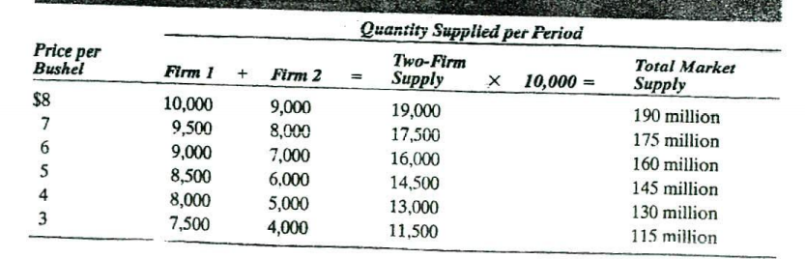
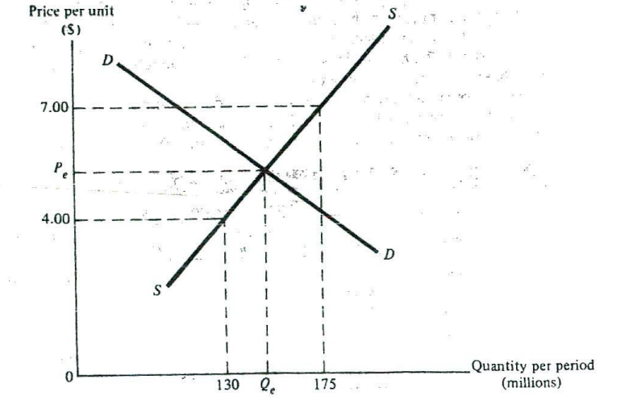
Losses and the Shutdown Decision

Simply because profit maximization is the objective of managers is no guarantee that a firm will actually earn economic or even normal profits. Oversupply, poor management, or high costs may prevent a firm from operating profitably at any rate of output. That is, maximum profit may actually be negative. The course of action adopted by managers of an unprofitable firm should be based on a consideration of the alternatives. One option would be to continue producing at the least unprofitable (i.e, smallest loss) rate of out put. Another would be to shut down operations and produce nothing. The best choice is the alternative that minimizes the firm's losses.
MONOPOLY

Although conditions facing a monopolist are much different from those of firms in perfect competition, the two types of firms have at least one thing in common—they do not have to compete with other individual participants in the market. Sellers in perfect competition are so small that they can ignore each other and consider the market environment as given. Al the other extreme, the monopolist is the only seller in the market and has no competitors.

Characteristics

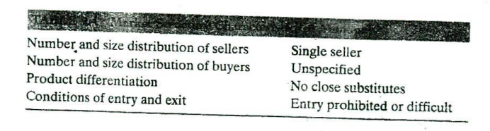
MONOPOLISTIC COMPETITION

The models of perfect competition and monopoly are useful, but there is a need to bridge the gap between these extreme forms of market structure. An important contribution is the model of monopolistic competition developed by Edward Chamberlin. Chamberlin observed that even in markets with a large number of sellers, the products of individual firms are rarely homogeneous. For example, consider men's shoes. In a large city there may be hundreds of shoe stores. But men's shoes may be highly differentiated in the minds of consumers. This product differentiation may reflect materials and workmanship of the shoes sold in a particular store, or it may be the result of effective advertising, Ile manner in which the store displays the shoes can be another source of product differentiation. An establishment with thick carpet and soft music may have an advantage over a firm that stocks its merchandise on shelves like a warehouse.

Characteristics

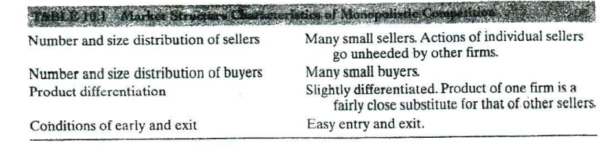
Evaluation of Monopolistic Competition

It is sometimes suggested that firms in monopolistic competition are inefficient. Figure 10.2 shows that the profit-maximizing output does not occur at the minimum point on the firm's average cost curve. Thus, it can be argued that the firm is operating at an inefficient output rate. In contrast, in chapter 9 it was demonstrated that the long-run equilibrium rate of output in perfect competition occurs at the point of minimum average cost. The difference in the two outcomes is the result of the downward-sloping demand curve in monopolistic competition Remember, the long run equilibrium is the point of tangency of the demand and average cost curves But because the demand curve is not horizontal, the tangency point cannot be at minimum average cost. However, this result does not necessarily imply inefficiency. The downward slope of the dejijand curve is the result of product differentiation in the market.

OLIGOPOLY

The term oligopoly comes from the Greek words oligos and poiis and means, literally, few sellers. Oligopoly is a common form of market structure in modern economic systems. The cereal, automobile, and steel industries in the United States would all qualify. However, oligopolies exist at the local as well as the national level. For example, although there are thousands of movie theaters scattered throughout the nation, the typical consumer considers only a few nearby locations. Other theaters that are farther away may offer lower prices or better food, but proximity is probably the dominant consideration. Hence. the market for movies faced by the individual consumer could he described as an oligopoly.

Characteristics

An oligopoly involves an unspecified number of buyers but only a small number of sellers. There is no precise limit on the number of sellers that a market can have and still be characterized as an oligopoly.

The key issue is not numbers, but rather the reaction of sellers to one another. In the three forms of market structure described thus far, there was no need for sellers to he concerned about the actions of individual competitors. The monopolist has no rivals, while firms in perfect and monopolistic competitive markets are too small to have a significant impact on other firms. In contrast, the actions of each firm in an oligopoly do affect the other sellers in the market.

The other two characteristics that categorize market structure are product differentiation and condition of entry and exit. The product sold in an oligopoly can be homogeneous or differentiated. If the product is homogeneous, the market is said to be a pure oligopoly The steel and copper markets in the United States would fit into this category. If the product is not h homogeneous, the market' s and differentiated oligopoly. The auto mobile and television industries are examples of differentiated oligopolies.

